**Written**

1. **What are the advantages of JSP over Servlet?**

The dynamic part of JSP is written in Java, so it is more powerful and easier to use. Secondly, JSP is platform independent whereas ASP is not. Pure Servlets : It is more convenient to write regular HTML than to have println statements that generate HTML. Allows separation of look from the content.

1. **What is JSP Scriptlet?**

In JavaServer Pages (JSP) technology, a scriptlet is a piece of Java-code embedded in the HTML-likeJSP code. The scriptlet is everything inside the <% %> tags. Between these the user can add any validScriptlet i.e. any valid Java Code. In AppleScript, ascriptlet is a small script.

1. **How will you handle the runtime exception in your JSP page?**

If the errorPage attribute of a page directive names a URL that refers to anotherJSP, and that target JSP page indicates that it is an error page (by setting the pagedirective's isErrorPage attribute to true ) then the exception implicit scripting language variable of that page is initialized to the offending java

**4. What are the implicit objects in JSP?**

|  |  |
| --- | --- |
| **Object** | **Type** |
| **out** | **JspWriter** |
| **request** | **HttpServletRequest** |
| **response** | **HttpServletResponse** |
| **config** | **ServletConfig** |
| **application** | **ServletContext** |
| **session** | **HttpSession** |
| **pageContext** | **PageContext** |
| **page** | **Object** |
| **exception** | **Throwable** |

**5. Difference between GET and POST in Java Servlets?**

* doPost has no limitations on paramater numbers while doGet has.
* doGet is faster than doPost.
* doPost is secured than doGet.

**6. What are the advantages of JSF?**

1. **JavaServer Faces architecture makes it easy for the developers to use. In JavaServer Faces technology, user interfaces can be created easily with its built-in UI component library, which handles most of the complexities of user interface management.**
2. **Offers a clean separation between behavior and presentation.**
3. **Provides a rich architecture for managing component state, processing component data, validating user input, and handling events.**
4. **Robust event handling mechanism.**
5. **Events easily tied to server-side code.**
6. **Render kit support for different clients**
7. **Component-level control over statefulness**
8. **Highly ‘pluggable’ – components, view handler, etc**
9. **JSF also supports internationalization and accessibility**
10. **Offers multiple, standardized vendor implementations**

**7. What is JSF life cycle and its phases?**

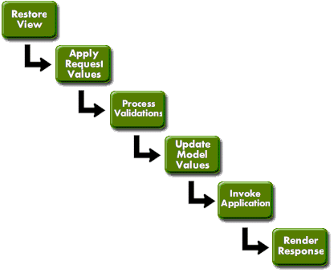

**8. 3: Identify the advantages of JSP over Servlet.**

a) Embedding of Java code in HTML pages

b) Platform independence

c) Creation of database-driven Web applications

d) Server-side programming capabilities

+

|  |  |
| --- | --- |
| |  | | --- | | **9.  What is deployment descriptor?** | |

An XML file provided with each module and J2EE application that describes how they should be deployed. The deployment descriptor directs a deployment tool to deploy a module or application with specific container options and describes specific configuration requirements that a deployer must resolve.

**10. What do you mean by  MVC in JSF?**

In the big architectural picture, JSF code is the V:

M - Business domain/Service layer (e.g. EJB/JPA/DAO)

V - Your JSF code

C - FacesServlet

In the smaller developer picture, the architectural V is in turn dividable as follows:

M - Entity

V - JSP/XHTML page

C - Managed bean

**10.  The JSP life cycle**

